H.T No
Regulations:
A20

Sreenidhi Institute of Science and Technology
(An Autonomous Institution)
Code No:8CC09 Date: 07-Aug-2024 (AN)

B.Tech III-Year II- Semester External Examination, August-2024 (Regular and Supplementary)

DIGITAL SIGNAL PROCESSING (ECM)
Time: 3 Hours Max.Marks:70

Note: a) No additional answer sheets will be provided.
b) All sub-parts of a question must be answered at one place only, otherwise it will not be valued.
c) Missing data can be assumed suitably.

Bloom's Cognitive Levels of Learning (BCLL)

Remember | L1 | Apply | L3 | Evaluate | L5
Understand | L2 | Analyze | L4 | Create | L6

Part - A Max.Marks:20
Answer all QUESTIONS

 |  | BCLL | CO(s) | Marks
1 | Check the linearity and causality of the system y(n)=x(n)+3x(n-2). | L4 | CO1 | [2M]
2 | Find the DFT of unit impulse sequence | L2 | CO2 | [2M]
3 | Calculate the number of complex additions required in 128 point DIT-FFT algorithm. | L2 | CO3 | [2M]
4 | Explain the mapping of S-plane into Z-plane | L3 | CO4 | [2M]
5 | Whate is meant by Gibbs phenomenon. | L2 | CO5 | [2M]
6 | What is the need of multirate signal processing | L1 | CO6 | [2M]
7 | Prove time shifting property of DFT | L2 | CO2 | [2M]
8 | Compare DIT and DIF of FFT algorithm | L5 | CO3 | [2M]
9 | Compare FIR and IIR filters? | L5 | CO4/5 | [2M]
10 | Classify discrete time signals with examples(any two) | L3 | CO1 | [2M]
Part – B Max.Marks:50
ANSWER ANY FIVE QUESTIONS. EACH QUESTION CARRIES 10 MARKS.

 |  |  | BCLL | CO(s) | Marks
11. | a) | The system output is y[n]=2x[n]u[n] where input x[n] and output y[n], determine whether it is i) Stable ii) Causal | L3 | CO1 | [4M]
 | b) | Consider the following difference equation y[n]-1/4y[n-1]-1/8y[n-2]=3x[n]  Find the impulse response of the system. | L3 | CO1 | [6M]
12. | a) | Determine the 4-point DFT of the given signal  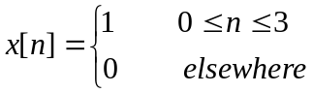 | L3 | CO2 | [5M]
 | b) | Prove the following properties of DFT  i) Circular time shift of a sequence  ii) Circular convolution | L2 | CO2 | [5M]
13. |  | Determine the FFT of the given signal data sequence x[n]={2,1,4,6,5,8,3,9} by decimation in time FFT? | L4 | CO3 | [10M]
14. | a) | Design a digital lowpass Butterworth filter using Bilinear Transformation method to meet the following specifications  Passband ripple ≤ 1.25 dB  Passband edge =200 Hz  Stopband attenuation ≥ 15 dB  Stopband edge =300 Hz  Sampling frequency = 2KHz | L4 | CO4 | [5M]
 | b) | Obtain the cascade realization for the IIR system function given by  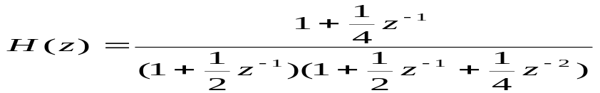 | L3 | CO4 | [5M]
15. | a) | Design a lowpass filter for the following specifications  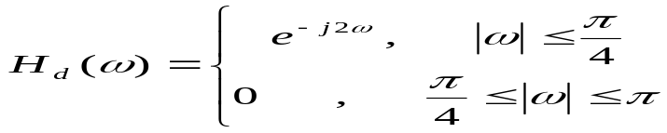  Use rectangular window 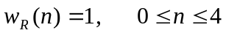 | L4 | CO5 | [5M]
 | b) | Realization a direct form structure for a linear phase FIR system  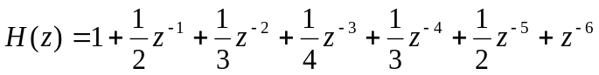 | L3 | CO5 | [5M]
16. | a) | Explain how the sampling rate can be decreased by the factor D? | L2 | CO6 | [5M]
 | b) | Explain how the sampling rate can be increased by the factor I? | L2 | CO6 | [5M]
17. | a) | Classify discrete time systems? | L3 | CO1 | [4M]
 | b) | Write short note on overlap save method. | L2 | CO2 | [3M]
 | c) | What is the main advantage of using FFT algorithms? | L2 | CO3 | [3M]
18. | a) | What is the purpose of the pre-warping process in the bilinear transform method? | L3 | CO4 | [4M]
 | b) | Write down the design procedure of linear phase FIR filters using windows | L2 | CO5 | [3M]
 | c) | Write any three applications of DSP processor. | L5 | CO6 | [3M]

-- 00 -- 00 –

